Insol Eastern Europe 2019, Ljubljana
Brief Notes on

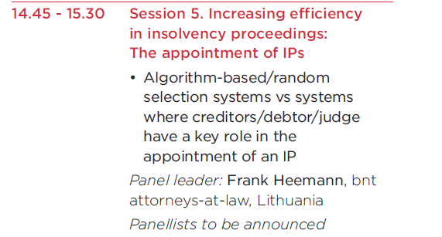

By panel member Hans-Georg Kantner, KSV1870 Vienna, ‚Austria

Topic:
this panel wants to shed some light into “increasing efficiency” by an algorithm based selection process for insolvency practitioners. Increasing efficiency may have two meanings: (i) making a process faster and cheaper and (ii) making a process hitting the target more reliably. The first deliberation will not seriously have to be taken into account, since the selection of a suitable IP for a particular proceeding will not eat up much of the judge’s time in comparison to other necessary steps to be taken (determining jurisdiction, determining inability to pay, determining other necessary formal elements of an application). Thus, the discussion will focus on a more reliable means of selecting the IP than by the jugdes own hand.

Determining factors for Selection of IP:
The famous German insolvency specialist of the 1930ies Ernst Jaeger coined the expression “Schicksalsfrage des Konkurses” in other words the vital decision to be taken in the context of the whole of the proceedings: the selection of a or the most suitable IP for the case.

In recent years insolvency proceedings have become very numerous across Europe while bedoming quite small on average. In addition to this, consumer insolvency cases play an ever increasing part in all the proceedings to be administered by courts and by IPs. Such small cases are probably similar in scope and requirement and the process of selecting a suitable IP are not demanding. Many IPs will be most suitable and any of them will probably deliver good work. However, there remains the ig case now and then and the selection process needs to be spot on in these cases as well. How do judges decide? They need proper training and expertise themselves and years of experience with the IPs in question. New judges need to rely on tradition and expertise handed down to them and will have to form their own opinions. Judges have been trained to make decisions. Judges have also been given independence and standing in society as to enable them to make these decisions responsibly and accountably. Contrary to decisions in civil and criminal matters, the appointment of the wrong IP cannot be readily mended by a court of appeal. In insolvency matters, time is of the essence and a second shot is usually not possible.

My own experience and horizon:
One tends to view the world from one’s own point of vantage. This is absolutely normal. Conferences like Insol are inherently designed to enable practitioners to learn from one another and to take with them experience and wisdom gained elsewhere. No system can claim to be perfect (B. Wilder); Systems are what their stakeholders make and perceive them to be. Austria is lucky in having strong creditor involvement in all insolvency proceedings and judges who perform a professional job: they work full-time as insolvency judges (concentration of all cases in one hand up to full employment of this person) and administer and coordinate the case from application to lifting of proceedings. They therefore see and feel the work of the IPs whom they have appointed. There are only few jobs in all auf Austria’s judiciary more desired than that of insolvency judge and most judges are made insolvency judges in the middle of their professional careers and stay in this position until retirement. This provides professionality and stability for all stakeholders involved. There is a list of IPs in Austria but this list is open to anyone. There are no professional requirements and no exams to pass; there is no particular body supervising IPs and/or monitoring and maintaining their professional work. This lies on the shoulders of judges who have fared well in appointing attorneys at law, thus relying on professional and ethical standards of the Austrian Bar. Cases in which the trust in Austrian attorneys at law as IPs has been disappointed happen but are exceedingly rare: maybe one case every 5-7 years and none of sizeable or even detrimental effect on the proceedings.

These judges therefore educate and create their own group of IPs: these are people inherently belonging to three generations: (i) seasoned IPs at the height of their professional experience; (ii) properly trained and tested IPs belonging to the next generation who have all proved to be good performers in their profession and (iii) young and eager IPs who have yet to prove to be able to handle big and controversial cases.

The random selection process:
Selecting the IP suitable for the job is a one-off chance and mending a wrong decision may well cost time, money and consequently also jobs and the whole existence of the insolvent company in question. Selecting IPs randomly can therefore only be viewed as the silliest of all options. It may be viewed as a temporary measure only in cases of a corrupt judiciary. But the objectivity of the selection process is just a sham, since the selection is neither transparent nor answerable. Flipping a coin can never produce a wrong decision – it is luck and the random factor that decide. It is not a decision but a random selection. The system may be hacked and manipulated. It furthermore assumes that everyone is equal in ability (which is a naïve expectation) and it does not create any incentive for IPs to perform well. Who monitors their performance or rather why strive to perform well if the next appointment will be made by randomizer anyway? Randomizers are unable to learn.

Artificial intelligence:
Yes, we live in a world of transition and artificial intelligence is out there. It may well be that machines and machine algorithms are better in many tasks compared to the human brain. Playing chess has been viewed as inherently complex, but since the late 1990ies machines have been beating chess masters on a constant level. The game of Go used to be viewed as many times more complex than chess, but in 2016 Google DeepMind beat the world Go champion Lee Sedol. This particular software is self learning. Artificial intelligence will change the way we work and live, undoubtedly. There is, however, still some way to go until we will be technically able and ethically willing to rely on computer algorithms making decisions in a court of law and choosing the IP most suitable for the particular case. I would expect and suggest that Legal Algorithms be tested first in courts where an appeal process may be able to correct a wrong decision. Value based judgements may be possible. I have yet to see them work well. Only after good convincing that machines can effectively mirror and outsmart the human legal brain would I be willing to accept IPs being selected by a computer algorithm.

