Risks for Insider-Financed Restructurings in Russia

Introduction

The first port of call in upstream restructurings is often the shareholders, particularly in private (closed) corporations, where the intention is to privilege the investment of a select few. When these companies contemplate restructurings, often they may be unable to obtain or extend conventional lending. Furthermore, the risk for the entrepreneurs from external (white knight) investment and the dilution of their capital may be something they are keen to avoid. In such situations, “recapitalizing” the company through soft loans is seen as a solution avoiding the need for greater investment in the equity. However, the issue is how these arrangements are treated should the company subsequently be unable to avoid formal insolvency proceedings. In a number of legal systems, such lenders are treated as “deferred” creditors, while, in others, they may be excluded entirely from the category of estate creditors. The risks for internally-financed restructurings are thus high if they do not work out.

The Definition of “Corporate Claims”

Traditionally, Russian insolvency law does not subordinate claims by persons simply because they are affiliated with the debtor. But, it does exclude “corporate claims”, which include shareholders whose claims arise from the fact of their shareholding. Such claims are not merely downgraded in rank, but are completely excluded from insolvency proceedings, with their holders unable to be counted on the list of creditors. The definition of “corporate claims” has been held to include claims for distribution of dividends and payment of share value upon exit from a company. That said, the status of shareholder loans fell into a grey area, although the Russian courts have decided, in a majority of cases until this year, that such arrangements derived from civil law transactions (i.e. loan agreements), rather than due to the “corporate connection” between the shareholder and the company.

The 2017 Case

This year, however, in the case of Sviridov v. Neftegazmash-Technologies (No. 308-ЭС17-1556(1), 6 July 2017), the Supreme Court of the Russian Federation has for the first time expanded the category of “corporate claims” to include shareholder loans and shareholder subrogation claims (under certain conditions). In this light, Russian jurisprudence is now following in the footsteps of both Germany and the US, where similar subordination rules were initially determined by the courts.

The case involved Neftegazmash-Technologies LLC, a Russian company engaged in the development, manufacturing and sale of industrial equipment, which had gone into insolvency. The major shareholder, Mr. Sviridov, who held 50% of the shares, filed a claim to be included on the list of creditors, arguing that a part of the debt originated from loans provided by him to the company, while another part derived from his satisfying a third-party claim due to the calling in of a guarantee he had provided (i.e. a subrogation claim). The lower courts had held that there was sufficient evidence of the claims being well founded and that he should therefore be ranked alongside the “unaffiliated” (i.e. “arm’s-length) creditors.

The Supreme Court Decision

The Supreme Court reversed the lower court, arguing for a more nuanced approach. For the court, of particular note was the special role played by shareholders in managing business affairs. In this context, shareholders are able to influence the debtor’s economic activity, by, inter alia, concluding agreements with the latter on terms not available to ordinary counterparties or by making strategic decisions through shareholders’ meetings. Therefore, in a situation of insolvency, shareholders should normally bear the cost of their inefficient management and should not compete with the claims of unaffiliated creditors. This stems from general considerations of good faith, reasonableness and fairness.

The Supreme Court was, however, of the view that not every shareholder claim deserved subordination. The court held that, in every case, the first step would be to analyse the nature of the relations in question, including the behaviour of the shareholder prior to insolvency. For instance, granting a loan (on favourable terms or otherwise) could be caused by a desire to compensate for poor managerial decisions, while avoiding making a contribution to the share capital. For that reason, shareholder loans could create a form of “controlled” indebtedness and thus harm the interests of both the debtor and its creditors. Where this is the case, courts should be able to treat loan contributions as contributions to the share capital, thus, inevitably, subordinating shareholders’ claims.

For the court, it is for a shareholder to provide proof to negate the corporate character of a claim. In particular, a shareholder can be required to disclose reasonable economic motives for providing the loan and explain the need for attracting the loan from an affiliated person or extend financing on non-market terms. If the real purpose of a loan is not profit making, but rather saving the failing business and managing its affairs, such a loan risks being re-characterized as an equity contribution.

In the instant case, the court assessed the reality of share ownership, particularly the fact Mr. Sviridov owned 50% of the company. The only source of funds through which the debtor was credited and the debt owed to the bank was repaid was in fact the money of the debtor itself, distributed to Mr. Sviridov as profit from the company’s economic activities. This potentially created a situation of an artificial circulation of funds, by which means the funds were firstly distributed by the company through shareholder dividends, the same funds subsequently being returned to the company via shareholder loans. For the court, if the distribution of profits led to a liquidity shortage, the subsequent channelling of funds by means of shareholder loans should be treated as stemming from corporate relations.

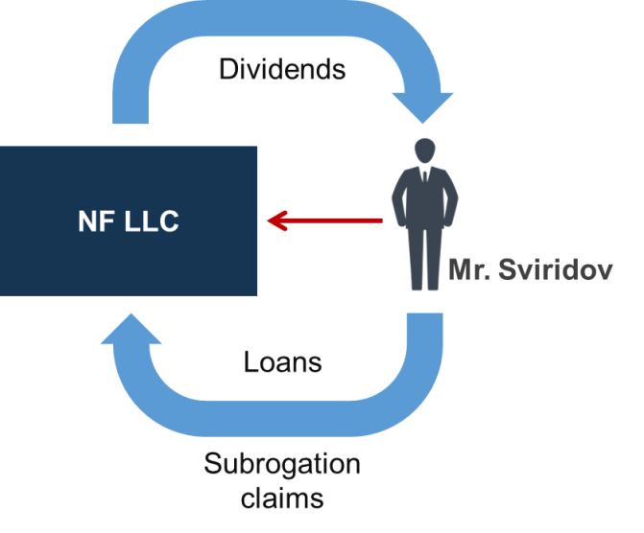

The Aftermath of the Decision

The decision in Sviridov v. Neftegazmash-Technologies does, nevertheless, leave certain issues unresolved. While the facts of the case could be seen as rather straightforward, other instances of shareholder loans could cause confusion and uncertainty. Two situations, in particular, spring to mind. Firstly, where a lender may have a non-controlling interest in an insolvent company, judicial subordination of its claims could lead to increased interest rates or, ultimately, stifle investment if lenders become risk-averse. Another situation is where an outside investor acquires stock and provides rescue financing for the failing business. In this case, subordinating claims of such an outsider-turned-insider investor could end up dis-incentivising rescue attempts and serve to kill off otherwise viable businesses.

In the last analysis, Russian courts will still have to develop clearer criteria to explain under what circumstances shareholder loans or equivalent transactions should be treated differently from loans granted by outsiders. In particular, should the amount of stock (or proportion of shares) held by the shareholder play the determining role?

Ilya Kokorin
Lecturer, Leiden University;
of Counsel, Buzko & Partners, Russia
i.kokorin@law.leidenuniv.nl

