Blockchain: A Chance for Turnaround Procedure Modernization
Yutong Zhang

Blockchain is a system consisting of cutting edge technologies. It brings value reconstruction to assets, including assets digitalization, standardization, registering and precise pricing. In “traditional” insolvency practice, there are three pain points: asset tracing and confirmation of its ownership; service and asset operation; and asset pricing and evaluation. There is a solid connection between all participants of turnaround procedure. They all can be registered into a blockchain system. This secured transparent and efficient connection is credited with the following attributes: the Asset Digitalization and Standardization are the fundamental base; Decentralized Registering are theoretical methods; and the Precise Pricing is a key solution. In a word, blockchain system could open the door for the modernization of turnaround procedure.

- The Nature of Blockchain System
The blockchain system plays important role in technology innovation. It was the first deployed in Bitcoin. Over the years, experts have expressed many different views on blockchain but, from a technology perspective, a distributed ledger, a consensus algorithm, and multiple nodes are the substantial elements to understanding the system.
In its essence, a blockchain system can be described as a shared and synchronized digital database which maintains a consensus algorithm and multiple stored nodes. These nodes are linked with each other through a distributed ledger. Information is sealed in blocks and stored on these nodes. Some experts found its advantages over other databases: the blockchain system can (1) reduce the need for trust between stakeholders; (2) build a secure value transfer system; (3) streamline business processes across multiple entities; (4) increase record transparency and ease of auditability. The advantages are based on the nature of blockchain system consisting of three subsets.
- Information System
As with internet, blockchain is an electronic network with information streaming. The first is participant information. They can choose whatever they want to share and upload the information into the blockchain. Once registered into the system, all participants’ information is available to other participants. The second is asset information. There are two types of digital assets on the chain: the first is assets generated on the chain which is defined by the distributed ledger. The other type is a digital representation of an existing off-chain asset, which means the off-chain asset is digitalized and represented on the network. Both types are presented as hash codes. The last kind of information is transaction information. When assets are traded, the transactions between participants are recorded. The blockchain records every movement and broadcasts it to the whole chain. There is no replication in this information system, every node and block is original. Different kinds of information are stored in the nodes, which are packaged into blocks.
- Incentive Mechanism
A blockchain system has a special incentive mechanism driven by a consensus algorithm and a distributed ledger. The algorithm is the core and the ledger is the fundamental structure. Distributed ledger ensures that all participants behave without any interference from others. While only by agreeing to the consensus, the participants could execute all the changes to the system. To some extent, the consensus algorithm is a pre-written protocol or contract for all participants.
The mechanism leads to crypto-economics or token-economics. Associated with the distributed ledger, participants fulfill production, distribution and consumption of goods and services in an encrypted, even tokenized, environment. Essentially, it is a reward system, participants get reward based on their activities and performance in the system.
- Trust Mechanism
A blockchain system is an algorithm-driven, secured, reliable environment, which provides a solution for data privacy and information security. Trust mechanism consists of two parts. The technologic one relies on the consensus algorithm and encryption algorithms. The structural one would be smart contract, which means all the contracts made by participants are shown as various computer programs. All smart contracts can run automatically once certain preconditions are satisfied. With the mechanism, digital assets become acceptable.
- Scalability with Clouding Computing, AI tech
No matter how business changes, data is the key issue. A blockchain system provides a new way to collect, store and protect data. AI technologies cloud computing and other technologies could associate with the system to make a better data analysis. For example, the system could make stored data integrity, accuracy, reality and consistency to meet the requirement of training data for the purpose of achieving better deep learning data analysis.
Based on its own nature, a blockchain system is more than a network structure. It can be applied to almost every aspect in the world. The reliable value is the key point: the blockchain system is the container for it. The digitalization is modernization. By hashing value into character strings, all assets could become digitalized in the chaining process. The digitalized hash code is the way in which value is retained.
- The Matching of Turnaround and Blockchain
Different business models have their own logics. For a blockchain system, all the logics lead to two results – to increase benefits or to reduce costs. Technologies like blockchain are always options for business like turnaround if the match points were found.
- Turnaround Modernization
As mentioned above, digitalization is a method for modernization. In the wave of the digitalization transformation, legal practice is still in the prehistoric era, let alone insolvency practice. The turnaround modernization benefits from not only the application of cutting edge technologies, but also the revolution of concept – from business logic driven to data driven. The precise targeting and precise pricing are the future of turnaround business.
- Modernization Solutions for Three Pain Points
Data is vital in next generation. It could be applied to turnaround digitalization in at least three aspects for business efficiency: asset tracing and confirmation of its ownership; service and asset operation; and asset pricing and evaluation.
Pain point | The importance to turnaround progress | description
Asset tracing and confirmation of its ownership | From asset generation to disposal, the asset trace and confirmation of its ownership are premises for precise turnaround. | 1. At the stage of asset generation, it is not clear that what the relationships about original rights and obligations among participants are.  2. At the progress during asset trade and the stage of asset disposal, it costs a lot to find out the history of asset circulation especially of judicial disposal.
Service and asset operation | From asset generation to disposal, service and asset operation are necessary safeguards. | There are lots of institutions and individuals who provide legal consulting, accounting and auditing services, asset operation and some other services to multi-sides of participants. It is hard to coordinate and trace the activities of the large group of servers.
Asset pricing and evaluation | From asset generation to disposal, asset pricing and evaluation are essence for precise turnaround. | The price is sensitive during the whole process while the evaluation and pricing are not relatively fair in relationship with information opacity and lack of precise calculation.

- The Junctions of Business and Technology
The three pain points are also the three progresses for value discovery. Both in the aspects of data analysis and value discovery, the blockchain system could be an ideal model for turnaround modernization. The three pain points are the junctions of the business and the system.
In the part of asset tracing and confirmation of its ownership, all the information about the assets and participants can be shown through the blocks. It shows the nature of information system. For example, the system could record the asset circulation history and every trade could even be made on the chains. Once the trades are completed, the system would broadcast the transfers of ownership to others for confirmation.
In the part of service and asset operation, service providers are no longer auxiliaries. They possess independent nodes in the system, which means they can play two kinds of roles that are motivated by the mechanism. The first one is the traditional role that lawyers, accountants and other intermediaries who provide legal consulting, accounting and auditing services, asset operation and some other services to multi-sides of participants. The second one is value finder who are active to analysis the potential trading opportunities in the market and facilitate deals.
In the part of asset pricing and evaluation, the blockchain system can generate the relatively precise calculation for the asset. Under the effect of trust mechanism, participants would trust and rely on the pricing and evaluation results. As the role of value finders, the service providers can even guarantee the pricing power in the market.
- Turnaround Consortium Blockchain
There are three kinds of blockchain systems – public blockchain, private blockchain, and consortium blockchain. The last one is the best choice for turnaround business for the consideration of business cost and secrets. Different channels could be added to the consortium blockchain in which information only is shared within permissioned nodes.
- Brief Introduction and Basic Model
On turnaround consortium blockchain systems, creditors, debtors (trustees or administrators), lawyers, accountants asset operation experts can work as a common market power. There are three basic logics for the system. The first one is that turnaround information can be broadcast to all participants. Anyone who is interested in the assets can contact debtors (trustees or administrators) and make deals. In the same time, the authority, community and creditors could get access to latest information about debtor’s turnaround process. The second one is that data about participants, assets and transactions could be stored in a structured form with several labels. (The last one is that data analysis could lead to precise and favorable results to all parts.
The turnaround consortium blockchain adds three important functions into the turnaround process. For the function of blockchain system building, all kinds of data could be registered to the system for the purpose of reliable asset and secured data. For the function of trade matchmaking, the debtors and investors/creditors, the debtors and intermediaries, the investors/creditors and intermediaries can strike bargains with each other on the system. For the function of data analysis, tech providers could help to analyze data in many ways including quantitative analysis, neuro-computing, and others to output precise results.
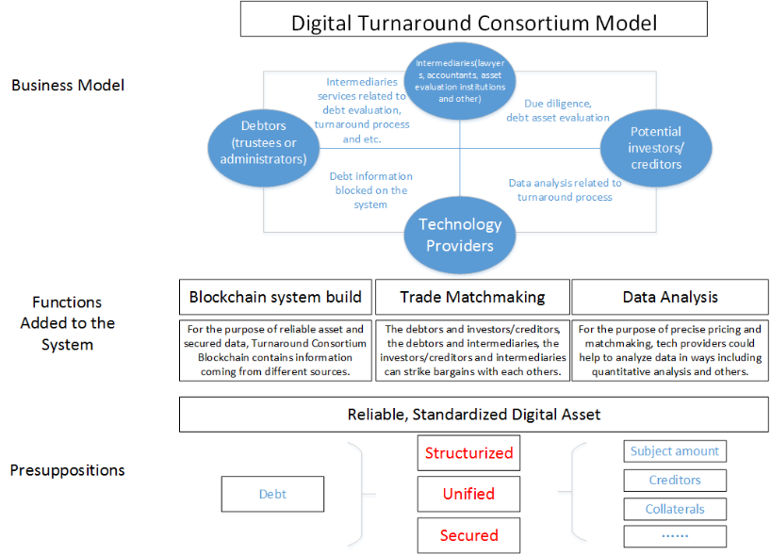

- Participants and their Roles
One of the advantages of the turnaround consortium blockchain is that different participants could be allocated different authorizations accordingly. Some institutions could play more than one roles in the system.

Participants | Role in business model | Authorization
 |  | Query | Registered to Blockchain system
Debtors (trustees or administrators) | 1. Put information about debts on the blocks  2. Negotiate with creditors and investors about the asset disposal |  | - Information about debt and debtors
Investors/Creditors | 1. Investors: seek good opportunities to invest and make deals with debtors  (trustees or administrators), intermediaries and tech providers  2. Creditors: negotiate with debtors(trustees or administrators), intermediaries and tech providers | - Debt information  - Transaction record  - DD Report  - Asset evaluation report  - Debt collection record | - Trades records
Intermediaries & asset operation experts | 1. Intermediaries:  - Lawyers and accountants: conduct DD to debts and debtors(trustees or administrators) for investors; handle legal issues about turnaround for debtors and creditors  - Insurance companies and other institutions: provide insurance and other financial innovation products  2. Asset evaluation institutions:  provide the asset pricing and evaluation;  3. asset operation experts: Provide real estate management, debt collection and other actions which can increase assets’ value | - Debt information  - debtors(trustees or administrators)  - debt collection record | - DD Report  - Asset evaluation report  - Trade/transaction files
Tech providers |  | - Debt information  - debtors(trustees or administrators) | - debt collection record
Authorities(Court, Trustee Office, etc.) | 1. Courts: provide judicial disposals about debt, conduct turnaround/reorganization process  2. Trustee Office: trustee management | - Debt information  - debtors(trustees or administrators)  - creditor information  - Transaction record  - DD Report  - Asset evaluation report  - Debt collection record

- the Designs about Allocated Authorization
- Interface and function
- Dashboard：display information about projects, assets, and system operation with GUI
- Information details：provide details about the user’s participation; provide API for query and upload according to allocated authorization
(2) Assets related information
- Basic information：loan amount, credit balance, interest rate, overdue condition, debtors and etc.
- Repayment information：details about repayment and debt collection
(3) Reports related information
- DD reports/results：sealed reports/results by intermediaries
- Evaluation reports/results：sealed reports/results by evaluation institution
(4) Transaction related information
- transaction history： times, prices, counterparties, and etc.
- Turnaround Process On the System
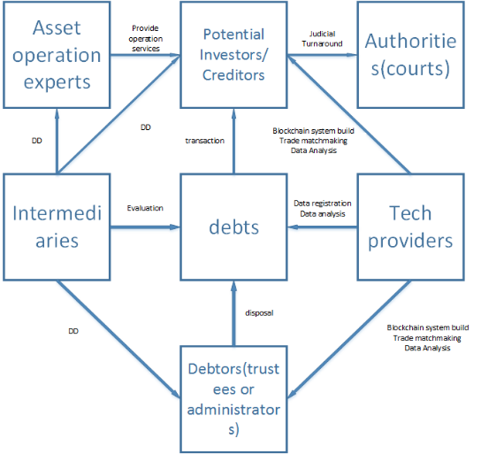
When everyone is registered to the system, the turnaround process seems more complex while efficient than traditional systems. From the view of debts, the core is how to deal with them associated with other participants on the system.
For debtors, sometimes the trustees are nominated by creditors conferences or administrators appointed by authorities. They have to dispose debts in order to turnaround the business. Tech providers help them to register all information on the system. Meanwhile, potential investors or original creditors would like to strike bargins with debtors about the debt reorganization or other disposal methods.Intermediaries and asset operation experts provide professional service to make the deals happen and valuable. Authorities supervise the whole process, sometimes step into the process to make sure everything proceeds effectively.
- Economic issues
- Economic Value
What exactly is a blockchain system? In the lens of contracts, a blockchain system can be seen as a nexus of contracts. Ronald Coaseused this theory to describe a company as well. While a blockchain system involves a nexus of both complete and incomplete contracts. For a firm, governance is the best way to save cost; for a market, contracts would be the only way to save cost; for a blockchain system, contracts and governance are both efficient with incentive and trust mechanism.
In the lens of organizations, a blockchain system is more like a catallaxy. Hayek once described the shape of a catallaxy -- “a special kind of spontaneous order produced by the market by people acting within the rules of the law of property, tort and contract.” The participants of it are (1) social, governed by social rules, (2) they have specialized/distributed knowledge, (3) they form their own plans, and (4) these are mutually coordinated through the market/price system. Unlike a market, a blockchain system can perform in a spontaneous order and facilitate all transactions.
From the perspective of economic value, there is a principle for the application of a blockchain system: The higher percentage of potential cost saving it might achieve, the more possible a blockchain system it would deploy.
- Cybersecurity
As the nature of a blockchain system, information network needs to maintain cybersecurity. A Blockchain system is materially easier to keep the goal. Hacker attacks could be detected easily if they hacked into the system; the risks from insiders could be eliminated effectively, such as attempts to conceal some information or overwrite data.
- Technology Standard
Blockchain systems, especially public blockchains, are open sourced. While for the consideration of valued assets and market orders, it is better to promote technology standards for the turnaround consortium blockchain. Usually, there would be at least three parts of the standards: (1) the process for data collection, aggregation, analysis, transaction, and storage; (2) the technological procedure for authorities to monitor the turnaround process; (3) the API used to connect with other capital market.
- Legal Concerns
- Legal nature and law Application
As indicated previously, a turnaround consortium blockchain is a magnificent catallaxy unlike a company, a joint venture, an incorporated business organization or partnership, There are not only bilateral activities, but also some multilateral ones. All the transactions and DD and evaluation activities are subjects to contract laws, tort laws, and IP laws.
- Conflict of law in Cross-border situations
There is always a conflict in cross-border situations. If the participants came from different areas, they might be subject to multi jurisdictions. When they reach deals on the turnaround system, will the deals or trades be seemed as valid in every jurisdiction? What if the participants reached two different deals on and off the chain separately, which one would be deemed as the valid one? Another conflict would be data in the cross-board turnaround processes. Data regulations vary with jurisdictions. What if the same data applied different laws? Different databases stored in different countries could face conflicting regulations.
- Data
On a distributed ledger, data can be stored in a variety forms and types. At this stage, blocks have limited storage capacity to keep vast amounts of data, such as movies or digital arts. Data is usually encrypted or hashed before it is added to a blockchain. Throughout the process, data is chronologically ordered in a manner that makes it difficult to tamper with information without altering subsequent blocks.
There are at least three issues concerned about data on the blockchain system. (1) privacy and business secret. There are always some kinds of data is sensitive to be exposed on the blockchain system. The individuals have their own privacy, the companies might have some business secrets. How to make a balance? There would be two aspects to answer the question. From legal perspective, only those which are allowed to disclose can register on the system, such as personal information under the control of a bankrupted social media company. From business perspective, only those which have potential market value might be disclosed. In order to fulfill the functions, the blockchain system could build some mechanisms. (2) Data ownership. Once registered onto the blockchain system, all participants’ data might be used beyond the purpose of turnaround process in the case of big data analysis. For example, the intermediaries could get access to debtor’s raw data to train their AI algorithms. To some extent, the information about debtors could also become a profitable asset even during the turnaround process. Can debtors benefits from intermediaries’ activities? (3) Data with GDPR. The GDPR is now a benchmark for personal data protection. It defines a data controller, the right to be forgotten, Data Protection by Design, Data Protection by Default and some other new regulation mechanisms. One technological way to solve these concerns is that to hash the data and only upload and store the hash codes on the system with timestamps and other encrypted methods. Further compliance should be embedded along with legal experts’ help. Comptech might be a solution.
- IP Law
In the block system, tech providers develop and maintain the network, and also provide data analysis services to other participants. Will they own the system? To what extent will tech providers get benefits from of the work and services? There are two approaches for that: the first is called the Bitcoin way. There is a core group of developers financed by Bitcoin foundation, everyone makes contribution to the system and the foundation is only an alliance for Bitcoin promotion without profit purpose. The second one is called Ripple way: Ripple’s platform was developed by a for-profit company, which has secured private investment. So the company owns the system, and can make money from it.
- Regulation
Authorities and regulators are important parts of the system. Apart from that participants could report their activities to them, e.g. accountants shall report their activities to some regulators for annual audits, the system could offer more sophisticated methods for regulators to get insight into network activity: regulators can register on the system and run nodes by themselves or make API queries and ask for disclosure about their major concerns. In other cases, participants offer alternative further methods. As the result, authorities and Regulators can take control of the consensus mechanism with powers. By those methods, the regulation would be conducted faster, in time, and more efficient.
- Conclusion
The blockchain system could transform the model of traditional turnaround process to be efficient. Not only intermediaries are empowered to play a richer role, but also the authorities could achieve a comprehensive regulation goal. Turnaround procedure is an ideal scenario which can directly deploy the system. When applying the turnaround consortium blockchain system, we should pay attention to some concerning issues, including data, economic value, regulation and so on.

Asset operation means real estate management, debt collection and other actions which can increase assets’ value.
Satoshi Nakamoto, Bitcoin: A Peer-to-Peer Electronic Cash System, see https://bitcoin.org/bitcoin.pdf.
Michèle Finck, Blockchains and Data Protection in the EU, Max Planck Institute for Innovation and Competition Research Paper No. 18-01.
Dr Garrick Hileman and Michel Rauchs, Global Blockchain Benchmarking Study 2017, Cambridge Centre for Alternative Finance.
Marc Pilkington, Bitcoin through the Lenses of Complexity Theory: Some Non-Orthodox Implications for Economic Theorizing, Handbook of the Geographies of Money and Finance, Pollard, J. & Martin, R. (eds.), Edward Elgar, 2017.
David S. Evans, Economic Aspects of Bitcoin and Other Decentralized Public-Ledger Currency Platforms, The University of Chicago, Institute for Law and Economics Working Paper Series.
See introduction about HyperLedger Fabric, see https://www.hyperledger.org.
Sinclair Davidson, Primavera De Filippi, and Jason Potts, Economics of Blockchain , see https://ssrn.com/abstract=2744751.
Qian Yao: Financial Revolution and Regulation in the Wave of Technology development, Tsinghua Financial Review, 2018.08
Dirk A. Zetzsche, Ross P. Buckley, Douglas W. Arner, The Distributed Liability of Distributed Ledgers: Legal Risks of Blockchain, EBI Working Paper Series(2017 – no. 14).
Lord Collins, Et. Al., Morris Dicey AND Collins On The Conflict Of Laws (2016); Adrian Briggs, Private International Law In English Courts (2014).
Michèle Finck, Blockchains and Data Protection in the EU, Max Planck Institute for Innovation and Competition Research Paper No. 18-01
For example, HyperLedger Fabric creates a mechanism on the blockchain system called channels. Participants can create channels according to their needs of information sharing. Other participants on the system could not get access to the information if they are not involved in the specific channel.
Article 4(7) GDPR.
Comptech is the abbreviation of compliance technologies, which is one part of Regtech, which means application of whole technology system in the situation of compliance for companies. There are lots of Comptech companies worldwide, some are focusing on GDPR and Privacy compliance. JD Finance Research Institute works on Regtech research continually as the first think tank which puts Regtech as its research priority in China, they have create a theoretical framework and have already applies to some practical fields.
David S. Evans, Economic Aspects of Bitcoin and Other Decentralized Public-Ledger Currency Platforms, The University of Chicago, Institute for Law and Economics Working Paper Series.
David S. Evans, Economic Aspects of Bitcoin and Other Decentralized Public-Ledger Currency Platforms, The University of Chicago, Institute for Law and Economics Working Paper Series.
Dr Garrick Hileman and Michel Rauchs, Global Blockchain Benchmarking Study 2017, Cambridge Centre for Alternative Finance.

