Inside Story – December 2018

Liability of Controllers and Insolvency Risks in Russia:
The Case of Dalnyaya Step LLC and HSBC

Ilya Kokorin, of Counsel, Buzko and Partners, Russia;
Lecturer, Leiden University
i.kokorin@law.leidenuniv.nl

Introduction

The insolvency case of Dalnyaya Step LLC (Dalnyaya Step, debtor) is well known both in Russia and abroad, particularly in the United Kingdom. It is unique for several reasons. First of all, the case spans across a decade, having started in 2006, closed in 2007 and reopened in 2015 (still pending). Secondly, the Russian insolvency proceedings were first recognized in the UK in 2016, only to have the recognition order set aside ab initio in 2017 on public policy grounds. Thirdly, in August 2018, the Russian Supreme Court refused to approve the settlement agreement reached between the liquidator of Dalnyaya Step and HSBC Bank LLC (HSBC Bank), a Russian entity affiliated with HSBC Bank PLC, and found the latter liable for the debtor’s insolvency with liability exceeding EUR 16 million.

This Inside Story will analyse this recent decision of the Russian Supreme Court and describe the potential risks it entails for members of corporate groups and banks serving their interests in Russia.

Background

Dalnyaya Step LLC was established in 1998. It was one of the Russian subsidiaries through which the investment strategy of Hermitage, a Guernsey unit trust founded by William Browder, was pursued in Russia. In the early 2000s, Hermitage became one of the largest portfolio investors in Russia with investments in major state-owned or partially state-owned companies, including PAO Gazprom. The management of Hermitage was carried out by HSBC Management (Guernsey) Limited (HSBC Guernsey).

In 2007, Dalnyaya Step LLC entered insolvency proceedings and was dissolved. In 2015, the Russian tax authority applied to the court to have the insolvency case reopened, asserting the debtor had been the subject of asset-stripping before the original insolvency filing. The tax authority (the only creditor in the case) claimed that, in the period between 2004 and 2005, more than EUR 24 million had been funnelled from the accounts of the debtor to other entities in the Hermitage group, leaving tax claims exceeding EUR 16 million unsatisfied. In 2015 Dalnyaya Step LLC was reinstated in the companies’ register and Mr. Nogotkov was appointed as a liquidator. On 8 July 2016, he was granted a recognition order under the UK’s CBIR 2006.

Meanwhile, in 2017, the Russian liquidator filed a directors’ liability claim against both HSBC Guernsey and HSBC Bank (defendants), arguing that they asserted control over the debtor and, as a result of their coordinated actions, Dalnyaya Step was forced into insolvency back in 2007. This was a rather difficult task to prove, considering the fact that HSBC Bank did not directly or indirectly control the debtor. In other words, it did not belong to the Hermitage corporate group allegedly orchestrating the asset-stripping. Nevertheless, the courts of the first instances ruled in favour of the tax authority. The case went to the Supreme Court.

- Decision of the Russian Supreme Court

The decision dated 6 August 2018 concerned two issues:

- sanctioning of the settlement agreement reached by the parties to the insolvency proceedings, and
- liability of “controlling parties” for causing the insolvency of Dalnyaya Step.

- Settlement Agreement

The liquidator of Dalnyaya Step and defendants reached a settlement agreement, which was presented for approval to the Supreme Court. The court closely scrutinized the text of the settlement agreement and found some of its provisions suspicious. For instance, the fact that under the proposed settlement, HSBC Guernsey and HSBC Bank agreed to pay an extra EUR 5 million to the insolvency estate was interpreted as having the aim of overcoming res judicata of previous decisions and was held unacceptable. According to the court:

“Situations in which parties by means of ostensibly legal mechanisms (procedural tricks), manipulate the court in order to realize their doubtful intentions, are unacceptable.”

It is not entirely clear what were the doubtful intentions of the parties implied by the court. The desire to overcome certain conclusions, reached in the first instances, by way of the settlement appears completely legal and as such does not violate any rights of third parties, not involved in the settlement.

In addition, the court was very critical of the provision under which HSBC Guernsey, while signing the settlement agreement, did not accept the jurisdiction of Russian courts for other related disputes. This legal instrument frequently phrased as “without prejudice” is commonly used in settlement negotiations and aims to safeguard the right of the party to raise jurisdictional objections in the future. As opposed to the interpretation and conclusion of the Supreme Court, this provision could not have limited the jurisdiction of Russian courts in further disputes. As a result, the court did not approve the settlement agreement.

- Liability of Controlling Parties

Having refused to sanction the settlement agreement, the Supreme Court needed to decide on the matter of directors’ liability. According to the applicable law as at the time the payments were made, if insolvency of a company was caused by its shareholders or other persons, who could give binding instructions or otherwise had an opportunity to direct its actions, such persons can be held liable for the outstanding debtor’s obligations. The crux of the dispute was whether HSBC Guernsey and HSBC Bank could give binding instructions or otherwise define the actions of Dalnyaya Step. The court answered affirmatively. Although the case of Dalnyaya Step is undoubtedly special due to the high political stakes involved (as confirmed by the courts in the UK), the reasoning of the Supreme Court could prove instrumental for further cases involving international group structures and intra-group transfer of funds.

Relations between parties involved

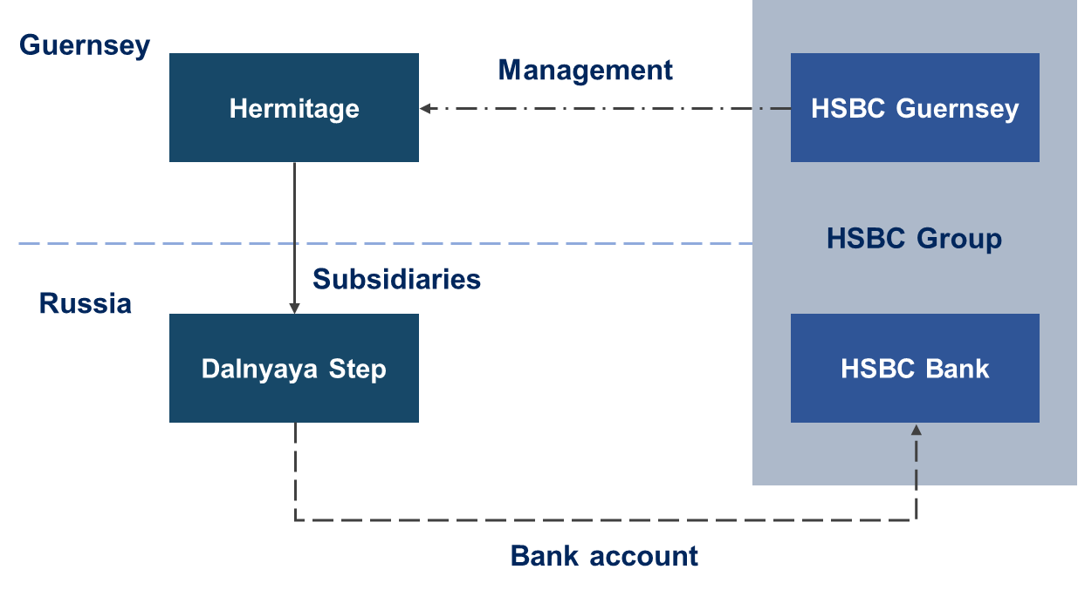

With respect to HSBC Guernsey, the court carried out the following deductive exercise:

- HSBC Guernsey conducted the management of Hermitage, which owned the debtor through several subsidiaries. Thus, “the company [HSBC Guernsey] controlled the debtor by controlling intermediaries in the hierarchy of a complex corporate structure.” The court did not look at how the management over Dalnyaya Step was actually exercised at the level of “controlling” entities in Guernsey.
- HSBC Guernsey failed to produce convincing evidence refuting the argument of its control over the debtor. Besides, the fact of such control was previously established in the judgment convicting the former liquidator of Dalnyaya Step of insolvency fraud.
- HSBC Guernsey was one of the beneficiaries of the asset-stripping, since, as a result of money transfer from “bad” (orphan) entity to “good” entities within the Hermitage corporate group, the group as a whole profited.

Thus, the control over the debtor by HSBC Guernsey was established through the aggregation of corporate ownership and other relevant factors. The situation over HSBC Bank, however, was much more complicated, as the bank was not a part of the Hermitage corporate group and did directly benefit from the intra-group transfers of funds. Still, the Supreme Court recognized HSBC Bank as the debtor’s controlling person on the basis of the following:

- HSBC Bank and HSBC Guernsey were part of the same HSBC group. Because of this, all subsidiaries of Hermitage in Russia were required to use the bank’s services. This was sufficient to hold HSBC Bank to be affiliated with HSBC Guernsey.
- The applications for transfer of funds from the debtor’s accounts were either not signed or did not have a seal of Dalnyaya Step. This, according to the court, indicated that HSBC Bank acted on behalf of HSBC Guernsey as the “initiator of the controversial operations”. To the bank’s objections, the court replied: “It is extremely unlikely and unrealistic that the bank could grossly violate the provisions of civil legislation […] and banking rules and perform 14 expense transactions by accident. It is even more improbable that as a result of the accidental withdrawal of funds without the order, such funds could accidentally end up in the accounts of corporate entities […] in the same bank.”

This reasoning is puzzling. It is based on assumptions and guesses, with no clear evidence of HSBC Bank’s involvement in the control or direction of Dalnyaya Step. Can simply belonging to the same group of companies and alleged violation of banking rules create control? In the absence of convincing evidence, the answer should be a clear ‘No’. This is particularly so in light of the extraordinary nature of directors’ liability in insolvency, which should remain an exception rather than a rule.

Summary

Recent data shows an ever-growing number of claims filed against (former) directors and other controlling persons in insolvency proceedings opened in Russia. Roughly every third insolvency proceeding involves claims against controlling persons. More than 20% of such claims are successful. The rules on ‘controlling persons’ and directors’ liability in insolvency are constantly evolving, both through case law and legislative reforms in this area. This is why, when dealing with Russian companies, the insolvency-related risks should never be underestimated.

For more on this, see Sorin Dolea, London High Court fails to recognize Russian insolvency proceedings (CIS Arbitration Forum, 23 February 2018).
This recognition was set aside by the High Court in December 2017 with the court finding that that the Russian liquidator failed to comply with the duty to provide full and frank disclosure in relation to the consequences for third parties that are not before the court that may flow from the recognition of the foreign proceeding. In the present case, such consequences concerned Hermitage-affiliated parties, including Mr. Browder (founder and CEO of Hermitage Capital Management Limited), and granting recognition to the insolvency proceedings potentially engaged political issues involving the Russian state. See Re Dalnyaya Step LLC [2017] EWHC 756 (Ch).
Decision of the Supreme Court of the Russian Federation dated 6 August 2018, case No. A22-941/2006.
Most probably, the defendants wanted to cleanse themselves off the stigma attached to “controlling persons”.
Article 56(3) Russian Civil Code; Article 10(4) Russian Bankruptcy Act.
See Resolution of the Plenum of the Supreme Court of the Russian Federation dated 21 December 2017, No. 53 “On some aspects related to holding controlling persons liable in insolvency”.
The size and frequency of subsidiary liability in business insolvency has beaten records (Fedresurs, 19 November 2018).
Recently, Federal Law No. 266-FZ dated 29 July 2017 added a whole new Chapter III.2 to the Russian Bankruptcy Act titled ‘Liability borne by the debtor's management and other persons in a bankruptcy case’, which consists of 13 articles.

