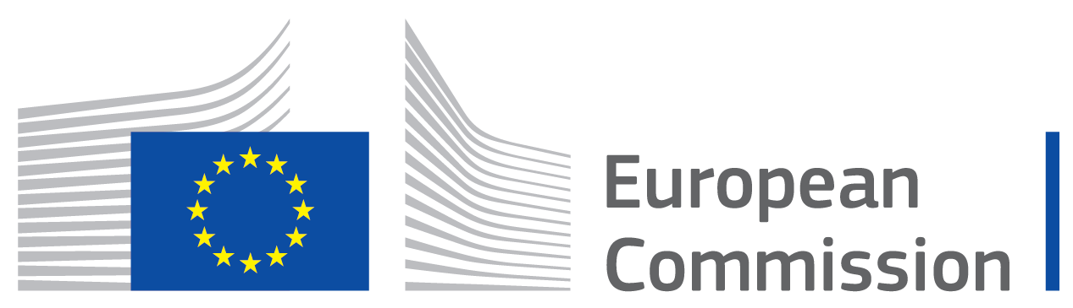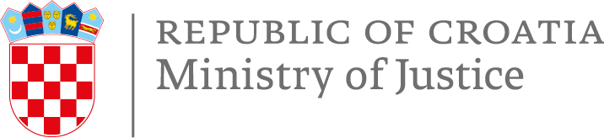

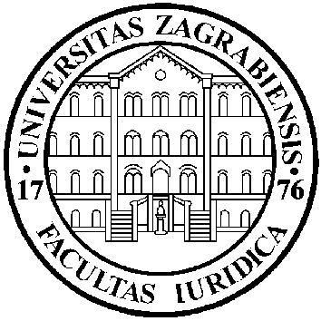
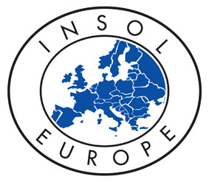

“INTERNATIONAL CONFERENCE ON APPLICABLE LAW IN CROSS-BORDER INSOLVENCY PROCEEDINGS”
Zagreb, 27th-28th March 2020
Venue: Faculty of Law of the University of Zagreb
Trg Republike Hrvatske 14, Second Floor, Room III.

PROGRAMME
FRIDAY 27 MARCH
08.00 - 09.00 REGISTRATION

09.00 - 09.30 WELCOME ADDRESS
Prof. Dr. Igor Gliha, Dean of the Faculty of Law of the University of Zagreb, Croatia
Ms Salla Saastamoinen, acting Director General, DG Justice and Consumers, European Commission
Ministry of Justice of the Republic of Croatia
Prof. Dr. Paul Omar, INSOL Europe

09.30 – 11.00 SESSION 1.
Panel Leader: Dr. Andreas Stein, Head of Civil Justice Unit in DG Justice and Consumers, European Commission
09.30 – 09.50 Prof. Dr. Ignacio Tirado, Universidad Autónoma de Madrid, Spain, Secretary-General UNIDROIT
Applicable Law to Rights in Rem in Cross-Border Insolvency Proceedings
09.50 – 10.00 Discussion
10.00 – 10.20 Prof. Dr. Francisco Garcimartin, Universidad Autónoma de Madrid, Spain
Applicable Law to Current Contracts to Which the Debtor is Party in Cross-Border Insolvency Proceeding, Including Termination and Acceleration (Ipso Facto) Clauses in Cross-Border Insolvency Proceedings
10.20 – 10.30 Discussion
10.30 – 10.50 Mag. Miha Žebre, LL.M, Legal and Legislative Officer, Civil Justice Unit in DG Justice and Consumers, European Commission
Applicable Law to Contracts of Employment in Cross-Border Insolvency Proceedings
10.50 – 11.00 Discussion

11.00 – 11.30 COFFEE BREAK

11.30 – 13.00 SESSION 2.
Panel Leader: Prof. Dr. Hrvoje Sikirić, Faculty of Law of the University of Zagreb, Croatia
11.30 – 11.50 Prof. Dr. Edward Janger, Brooklyn Law School, USA
Choice of Law and Entitlement Baseline in Rescue
11.50 – 12.00 Discussion
12.00 – 12.20 Prof. Dr. Andreas Piekenbrock, Faculty of Law of the University of Heidelberg, Germany
International Jurisdiction for Insolvency Law Avoidance Actions
12.20 – 12.30 Discussion
12.30 – 12.50 Prof. Dr. Jasnica Garašić, Faculty of Law of the University of Zagreb, Croatia
Applicable Law for Insolvency Law Avoidance
12.50 – 13.00 Discussion

13.00 – 14.00 LUNCH BREAK

14.00 – 15.30 SESSION 3.
Panel leader: Prof. Dr. Nina Tepeš, Faculty of Law of the University of Zagreb, Croatia
14.00 – 14.20 Prof. Dr. Paul Omar, INSOL Europe
Recognition and Enforcement of Insolvency-Related Judgments
14.20 – 14.30 Discussion
14.30 – 14.50 Bartosz Groele, Partner, Tomasik & Pakostewicz & Groele, Kraków, Poland
Effects of a Foreign Insolvency Proceedings on Arbitral Proceedings in the State of Recognition
14.50 – 15.00 Discussion
15.00 – 15.20 Zoltan Fabok, Special Counsel, DLA Piper Posztl, Nemescsói, Györfi-Tóth & Partners Law Firm, Budapest, Hungary
Effects of Foreign Insolvency Proceedings on Enforcement Proceedings in the State of Recognition
15.20 – 15.30 Discussion

15.30 – 16.00 COFFEE BREAK

16.00 – 17.00 SESSION 4.
Panel leader: Prof. Dr. Hana Horak, Faculty of Economics & Business of the University of Zagreb, Croatia
16.00 – 16.20 Jose Garrido, Senior Counsel and Supervisor, International Monetary Fund, Legal Department
Applicable Law for Lodging, Verification and Admission of Claims in Cross-Border Insolvency Proceedings
16.20 – 16.30 Discussion
16.30 – 16.50 Simeon Gilchrist, Partner, Edwin Coe LLP, London, UK
The Post Brexit Landscape: The Known Unknown: Choice of Law and Applicable Law Issues
16.50 – 17.00 Discussion

17.30 – 19.00 SIGHTSEEING - ZAGREB

20.00 – 23.00 DINNER

SATURDAY 28 MARCH
09.00 – 10.30 SESSION 5.
Panel leader: Simeon Gilchrist, Partner, Edwin Coe LLP, London, UK
09.00 – 09.20 Leif Clark, Former US Bankruptcy Judge, today mediator, arbitrator and consultant, San Antonio, Texas, USA
Legal Position of a Foreign Insolvency Representative in the State of Recognition According to the UNCITRAL Model Law on Cross-Border Insolvency and the USA Bankruptcy Code
09.20 – 09.30 Discussion
09.30 – 9.50 Dr. Miodrag Đorđević, Vice-president of the Supreme Court of the Republic of Slovenia, Slovenia
Legal Position of a Foreign Insolvency Practitioner in the State of Recognition According to the European Regulation on Insolvency Proceedings
09.50 – 10.00 Discussion
10.00 – 10.20 Karol Czepukojć, Attorney at law, Licensed Restructuring Adviser, Wardyński & Partners, Warsaw, Poland
Applicable Law to Contracts Relating to Real Estate in Cross-Border Insolvency Proceedings
10.20 – 10.30 Discussion

10.30 – 11.00 COFFEE BREAK

11.00 – 12.30 SESSION 6.
Panel leader: Prof. Mag. Mag. Dr. Tomislav Borić, Faculty of Law of the Karl Franzens University of Graz, Austria
11.00 – 11.20 Prof. Dr. Janis Sarra, University of British Columbia, Canada
Debtor’s Disposal of Assets After the Opening of Insolvency Proceedings and Protection of Third-Party Purchasers
11.20 – 11.30 Discussion
11. 30 – 11.50 Prof. Dr. Gerry McCormack, School of Law of the University of Leeds, UK
Applicable Law to Insolvency Law Set-Off and the European Insolvency Regulation
11.50 – 12.00 Discussion
12.00 – 12.20 Prof. Dr. John Pottow, Law School of the University of Michigan
Normative Consideration on the Protection of Local Interests in Cross-Border Insolvency
12.20 – 12.30 Discussion

12.30 – 13.30 SESSION 7.
Views of International Organizations

13.30 – 13.45 CLOSING REMARKS

13.45 – 14.45 LUNCH

Programme subject to alteration.

