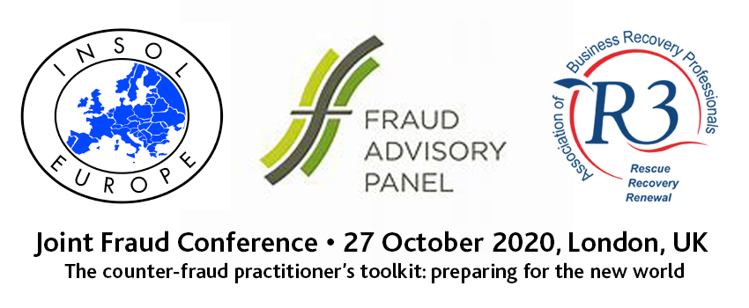
Programme
[Final draft as at 03/03/20]

08:30 | Registration, refreshments and exhibition
09:00 | Chair’s welcome and introduction [Frances Coulson]
09:15 | Keynote session 1: The changing nature of financial crime and the global response  Financial crime ranges from basic theft or fraud to large-scale operations masterminded by organised criminals with a foot on every continent. Interpol plays a dual role in tackling financial crime by combining everyday support to member countries with targeted operations and joint investigations, often working in collaboration with organisations outside the law enforcement community.  This session will explain the work of Interpol, some of the emerging threats they are seeing, how they work with organisations beyond law enforcement, and some recent successes – particularly Operation First Light (targeting call centres) and their work to stem the use of cryptocurrency in money laundering.  Suggested speaker: Paul Stanfield, Director for Organised and Emerging Crime, Interpol; alternate EUROPOL or Lynne Owens/Ben Russell, National Crime Agency
09:45 | Panel session 1: tackling rogue companies– a shared responsibility  The abuse of companies to facilitate fraud and money laundering has been a subject of much interest and debate over the past ten years. Yet new cases continue to come to light exposing the ease in which companies can be set up both here and abroad for nefarious reasons.  This panel session will examine what, if any, progress has been made to address this problem, what more can be done, and the important role that professionals can play, drawing upon a broad range of perspectives from the media, government, not-for-profit sectors.  Suggested speakers: (no more than 4 people, plus chair): BEIS, OCCRP (media group which broke the latest story about Formation House) or James Hurley from The Times, Transparency International UK or Global Witness + 1 private sector professional or public sector international fraud forum. Professor Alan Kabki, University of Netherlands (Bart to invite)
11:00 | Refreshments and exhibition
11:30 | Breakout stream 1A: General  Chair: Frances Coulson | Breakout stream 1B: International  Chair: Bart Heynickx
 | Making fraudsters pay: update on the use of UK compensation orders and private prosecutions to recover fraud losses.  Proposed speakers  [up to 2 speakers max]  XXX, Insolvency Service AND/OR  Andrew Sutcliffe QC, 3VB on Unexplained wealth orders AND/OR  Kate McMahon/Tamlyn Edmonds, EMM | Recent developments and innovations in cross-border asset-tracing and recovery.  Proposed speakers  [up to 2 speakers max]  Stéphane Bonifassi, Bonifassi Advocats & Co-founder of the International Academy of Financial Crime Litigators [France]  Kevin Hellard, Grant Thornton & incoming president of Insolvency Practitioners Association
12:30 | Lunch, networking and exhibition
13:30 | Panel session 2: The Great Crypto Heist: Beyond OneCoin  This session will explore what practical lessons can be learnt from OneCoin to protect the public (and potential investors) from similar future investment frauds based on new and emerging technologies. As part of this it will consider what type of official messaging might help prevent victimisation, the role of regulators and law enforcement and how AI and the blockchain itself might prevent, detect and deter.  The Times described OneCoin as ‘one of the biggest scams in history’. Victims from around the world invested up to $4bn in OneCoin which was promoted as a cryptocurrency but was in fact nothing more than a Ponzi scheme designed to exploit investors limited understanding of cryptocurrencies and the blockchain to defraud them.  Possible speakers: Jamie Bartlett (journalist who investigated the scam), Jen McAdam (victim of the scam), Financial Conduct Authority or City of London Police (regulator/investigators), UK Finance
14:30 | Breakout stream 2A (General)  Chair: Frances Coulson | Breakout stream 2B (international)  Chair: Carmel King
 | Secret agents, smart contracts and cryptoassets: recovering funds in cryptocurrency frauds  Proposed speaker  Catherine Naylor, Gowling WLG  Matthew Lavy, 4 Pump Court | Digital forensics: Gathering evidence in the online world (covering international aspects of collecting digital evidence in multiple jurisdictions and latest challenges/innovations/developments)  Proposed speaker  XXX, Deloitte or PWC  Digital investigation BV
15:30 | Refreshments and exhibition
16:00 | Keynote session 3: Tackling fraud against the EU budget: what to expect from the new European Public Prosecutors Office  This session will provide an overview of the new European Public Prosecutors Office which is due to begin operation at the end of 2020 and will have the ability to bring judgment crimes against the EU budget such as fraud, corruption or serious cross-border VAT fraud.  XXX, European Public Prosecutors Office
16:30 | Keynote session 4: Beyond Brexit: What the future of tackling economic crime looks like (including extradition and Europol).  James Brokenshire MP, Minister of State for Security [responsible for economic crime]
16:50 | Chairman’s closing remarks
17:00 | Drinks reception and networking
18:30 | Close

