INSOL Europe, Dublin panel: Cross-border schemes and plans: How they work in different jurisdictions
Restructuring and insolvency analysis: A panel of experts at INSOL Europe’s 40th annual conference in Dublin compared and contrasted: (i) Irish examinership and schemes, (ii) UK restructuring plans and schemes, (iii) Dutch WHOA schemes and (iv) German StaRUG schemes. Written by panellists: Kathy Stones of LexisPSL (UK), Marcel Groenewegen of CMS (The Netherlands), Michael Murphy of McCann FitzGerald LLP (Ireland), Riaz Janjuah of White & Case LLP (Germany) and chair of the panel session, Chris Laughton of Mercer & Hole (UK).
Restructuring and Second Chance Directive
Many countries have been prompted to revamp their restructuring laws following the EU’s introduction of Directive (EU) 2019/1023 of the European Parliament and of the Council of 20 June 2019 on preventive restructuring frameworks, on discharge of debt and disqualifications, and on measures to increase the efficiency of procedures concerning restructuring, insolvency and discharge of debt, and amending Directive (EU) 2017/1132 (the Restructuring and Second Chance Directive).
INSOL Europe, Dublin panel
A panel of experts at INSOL Europe’s 40th annual conference in Dublin on 4 March 2022 compared and contrasted the restructuring regimes in the following countries:
- Ireland
- UK
- Netherlands
- Germany
Three long-established procedures, Examinership and Schemes in Ireland and Schemes in the UK, were compared with three newer procedures, Restructuring Plans in the UK, WHOA in the Netherlands and StaRUG in Germany. The focus was the schemes’ or plans’ efficacy in cross-border restructuring.
A summary of the findings appears below:
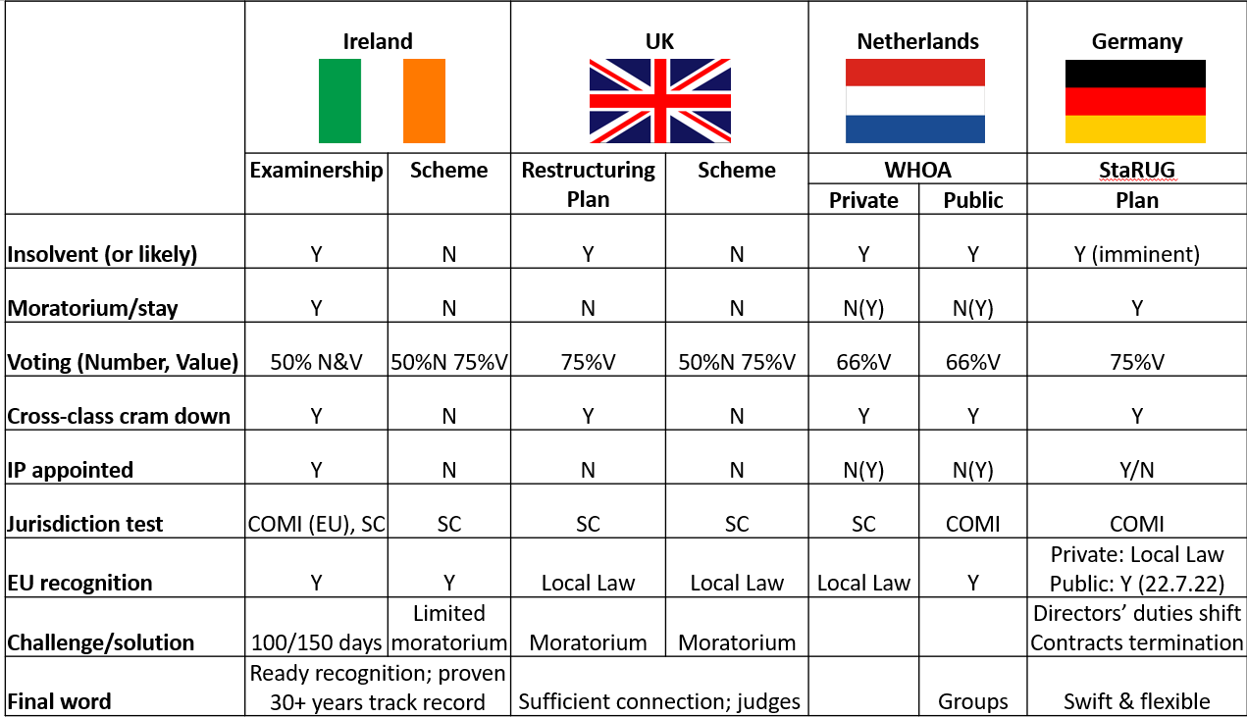

Ireland (summary by Michael Murphy of McCann FitzGerald LLP)
Examinership
Examinership is a well-established restructuring process in Ireland that has gained significant international attention. The process was introduced 30 years ago and is largely modelled on the US Chapter 11 process. It is user-friendly and its concepts are very familiar to advisors in an international context.
Examinership is available to a company or companies in financial difficulty but who otherwise have a reasonable prospect of survival as a going concern. The essential features of the process are:
- a comprehensive moratorium triggered automatically on filing the petition for the appointment of an Examiner. The moratorium extends to third party guarantors, even where they remain outside of the process. The Examiner is nominated by the applicant who can be the company, a shareholder or creditor. The Examiner is appointed by the High Court and the process runs under the supervision of the court. Throughout the process, existing management remain in place and the company continues to trade. The Examiner sits alongside management but in certain circumstances can apply for some or all of the directors’ powers
- an EU company can avail of the process once its centre of main interests (COMI) is in Ireland. A non-EU company can also use the process once it has a sufficient connection to the jurisdiction
- the Examiner has a maximum period of 100 days within which to formulate proposals for the scheme of arrangement, convene meetings of members and the different classes of creditors, take a vote on the scheme and report back to court. A confirmation hearing, when the court will decide whether or not to approve the Examiner’s scheme can take place outside of the 100 day period. As a temporary COVID relief measure, the 100 day period can be extended to 150 days
- cross-class clam down is a well-established feature of Examinership. The approval thresholds required to trigger the court’s entitlement to approve the Examiner’s scheme of arrangement are low. A majority in number and value of just one class of impaired creditors is required
- examinership has delivered a very broad range of outcomes. It has been used to implement pre-packs, the write down of debt and creditors’ claims, including contingent liabilities, extinguish and replace equity, facilitate new investment and debt for equity arrangements
- examinership has been used as a parallel process with US Chapter 11 proceedings and a local restructuring process in Norway. It has been used to write down Irish and non-Irish law governed debt and to repudiate Irish and non-Irish law governed contracts. Any damages claims arising from the repudiation can be written down by the Examiner’s scheme
- importantly, examinership has been recognised in England under Section 426 of the UK Insolvency Act 1986 and can be used to write down English law governed debt, thereby side-stepping the ‘Rule in Gibbs’
Statutory Schemes of Arrangement
- the Irish statutory scheme of arrangement provisions have been on our Statute books for over 60 years and largely mirror the UK provisions
- a scheme of arrangement can involve any compromise or arrangement between a company, its members or creditors or any class of them. The process typically involves an application to court to convene scheme meetings, a creditor vote and a sanction hearing
- unlike Examinership, a scheme of arrangement is not an insolvency process and there is no requirement to establish insolvency. It does not trigger a moratorium, albeit the court has power to stay proceedings. Furthermore, there is no need to establish that the company has an undertaking or is a going concern. There are no prescribed time limits within which the process must conclude
- the Irish scheme of arrangement provisions are flexible. They have been used to vary contractual arrangements, implement waivers and debt for equity arrangements, amend terms of finance documents and deliver third party releases
Final word on Ireland
- Ireland remains a firm member of the European Union. Examinership is listed in Annex A of the Recast Regulation on Insolvency 2015/848 (the EU Insolvency Regulation), facilitating recognition of the process throughout the EU. Schemes of arrangement can be also recognised in the EU using the Recast Judgments Regulation. Both processes have also been recognised in the US using the Chapter 15 procedure
- Ireland has a proven track record in international restructuring, with a responsive and experienced judiciary and a fast track appeal court. Irish decisions have also been relied upon in an international context
UK (summary by Kathy Stones of LexisPSL R&I)
In the UK, schemes of arrangement have been used for many years and are available without proving insolvency, arising under the Companies Act 2006 (rather than the Insolvency Act 1986). Indeed, statistically around 50% of all scheme cases currently going through the courts are solvent schemes.
Voting requires approval by 75% in value of all those present and voting in each class, plus a majority in number (the numerosity requirement).
Part 26A Restructuring plans are a new tool available since June 2020 sharing many of the same features as schemes, with the addition of Cross Class Cram Down where certain conditions are met. Insolvency does not need to be proved, rather that the company ‘has encountered or is likely to encounter financial difficulties’ (and Hurricane Energy shows the need for a burning platform). Voting is slightly easier requiring 75% in value of all those present and voting in each class (although dissenting classes can be crammed down) and there is no numerosity requirement.
For both schemes and plans, there is no requirement for an insolvency practitioner to be appointed, but in complex cases they generally are appointed (alongside the existing directors, who remain in position as this is a ‘debtor in possession’ process) to oversee implementation of the plan/scheme.
The jurisdiction test for both is simply the lower sufficient connection test, rather than COMI. In the last year alone (2021), the English courts have welcomed schemes and plans from companies incorporated in countries such as: Peru, Spain, Mauritius, Norway, Malaysia and the Netherlands.
Post-Brexit, recognition continues as before; schemes and plans were never in Annex A of the EU Insolvency Regulation and so it is ‘business as normal’. During the hearing, the plan proponent (usually the debtor company) must provide expert evidence as to how the scheme/plan will be recognised in key jurisdictions within which it operates or has assets/key creditors. This will depend on local law, which varies from country to country. INSOL Europe and LexisPSL have produced a helpful research paper summarising recognition in each EU Member State: https://www.insol-europe.org/technical-content/recognition-in-third-states (the findings are also summarised in INSOL Europe’s journal: Eurofenix, Winter 2021).
One key challenge levelled at schemes and plans in the UK could be the lack of an automatic moratorium; however this has not been a problem in practice, perhaps given the tendency to bind key financial creditors with lockup agreements early in negotiations. In any event, a standalone moratorium can be applied for whilst a scheme/plan is negotiated.
Final Word on the UK
- the UK has some fantastic, pragmatic, specialist judges to hear plan/scheme cases and a great track record
- the low sufficient connection test is appealing for foreign companies
- if the finance documents contain English law governing clauses, then UK schemes/plans may be the only option, unless you can get around the Gibbs rule
The Netherlands (summary by Marcel Groenewegen of CMS)
As from 1 January 2021 the Dutch "scheme", already widely known as "WHOA", has been introduced as a new restructuring tool. Combining certain elements of the US Chapter 11 and the English Scheme with typical Dutch law innovations, the WHOA has had a successful start and continues to grow in popularity. Currently approximately 150 WHOA proceedings, mainly for small and medium size enterprises in financial distress, have been launched and approximately 90 court decisions have published.
A key feature of the Dutch WHOA is the possibility to chose between public and private proceedings. Whilst the first option benefits from EU-wide recognition under the EU Insolvency Regulation (via Annex A), the latter is a confidential procedure with very limited public exposure, allowing the debtor to restructure its debts in relative quietness.
The Dutch courts have a reputation of being very accessible and this also applies for granting access for foreign entities to the WHOA with a flexible "sufficient connection" threshold, which can be fairly easily met.
Once opened, the WHOA proceedings offer not only the possibility of a cross class cram down composition (with votes only calculated by amount, so no head count) but also of a general moratorium and an option to terminate burdensome (long term) contracts on short notice, following which any damage claims resulting from such termination can be compromised and crammed down as well.
Dutch courts have installed specialised WHOA-chambers to hear cases and judges of such chambers have taken extensive courses to warrant the quality of WHOA-decisions. Costs can be relatively low compared to other jurisdictions.
Final Word on the Netherlands
• with the WHOA The Netherlands has become a very attractive jurisdiction for cross border restructurings, especially given the low entry test for companies with no COMI in The Netherlands
• the WHOA is very much "debtor in possession" and court involvement can be very limited
• cross class cram down and the option to obtain a general moratorium for a maximum period of 8 months allow for a flexible restructuring tool, which can be used in private (non-public) proceedings as well
• relatively low costs and the availability of well trained and specialized courts (which rule in the highest instance with no option for lengthy and costly appeal proceedings) provide for a speedy and cost efficient restructuring instrument with a high level of deal certainty
Germany (summary by Riaz Janjuah of White & Case LLP)
On 1 January 2021 the StaRUG introduced the new Preventive Restructuring Framework that fills a gap in German restructuring law. In particular, the new Preventive Restructuring Framework allows for an implementation of a restructuring plan by way of outvoting dissenting creditors and including the possibility of a cross-class cram-down.
Eligibility
A debtor is eligible to use a Preventive Restructuring Framework if it is imminently illiquid (drohend zahlungsunfähig) i.e. the debtor must more likely than not become unable to pay its debts within the next 24 months; further, the debtor must not (yet) be illiquid or over-indebted as in this case the directors of the debtor are under the strict duty to file for formal insolvency proceedings.
Moratorium
The debtor may apply for a moratorium on foreclosure and enforcement (also with regard to third-party security granted by the debtor’s affiliated companies). The Moratorium will initially be granted for a maximum period of three months. This period may be extended up to eight months, if the debtor has requested the judicial confirmation for a Restructuring Plan, approved by the creditors.
Restructuring Plan - Voting
The Restructuring Plan lies at the heart of the Preventive Restructuring Framework. It allows for modifications of liabilities and security rights granted by the debtor as well as in certain cases the underlying contractual relationships (gestaltbare Rechtsverhältnisse). Excluded are, inter alia, employee claims and certain tort claims. Further, an impairment of third-party security granted by the debtor’s affiliated companies can be agreed by the parties to the Restructuring Plan, but the secured creditors will need to be compensated for such an impairment. In addition, an infringement of shareholder rights, for example in the form of capital measures or the transfer of share or membership rights (including a debt-for-equity swap) can be part of the Restructuring Plan.
The debtor can flexibly choose which (groups of) stakeholders to include in the Restructuring Plan. The choice must be reasonable and within each group, all creditors shall receive the same rights. To adopt the Restructuring Plan, a majority of 75% by value of claims within each group is required.
Cross-class Cram Down
Further, the StaRUG provides for a cross-class cram-down mechanism: A dissenting class can be “crammed down”, if: (i) the majority of classes vote in favour of the Restructuring Plan; (ii) members of the dissenting class can be expected to be in a position that is not worse than without the Restructuring Plan; and (iii) members of the dissenting class receive an adequate share in value created by the Restructuring Plan. A class will be deemed to participate adequately in the value of the Restructuring Plan, if: (i) no other creditor receives any value in excess of the amount of its claim; (ii) neither a subordinated creditor, the debtor nor the shareholders receives a value not fully compensated by a contribution into the debtor's assets (the so-called absolute priority rule); and (iii) no equal ranking creditor is better off than the creditors of the class concerned. In certain cases the law provides for exceptions to the absolute priority rule, for example in situations where the debtor or shareholders retain an interest in the company’s assets, provided that their participation is necessary for the continuation of the company in order to achieve the added value of the Restructuring Plan, or the impairment of the rights of creditors is marginal, such as, for example, in case their rights are not impaired and the maturity dates of their claims are deferred by no more than 18 months.
Appointment of IP
Generally, the debtor's management remains in full control of the company and its business operations. However, in certain cases the Restructuring Court will appoint a so-called Restructuring Officer. Examples are where (i) the Restructuring Court orders a comprehensive set of stabilisation measures affecting substantially all creditors; or (ii) a cross-class cram-down is required.
Jurisdiction Test
In general, all debtors with a COMI in Germany except for Financial Institutions are eligible for the Preventive Restructuring Framework.
EU Recognition
Public Preventive Restructuring Frameworks have been in included in Annex A of the EU Insolvency Regulation. Such proceedings will be recognised within the EU automatically after 17 July 2022, once the respective rules for publication have come into effect. For non-public Preventive Restructuring Frameworks there is no automatic recognition and it has yet to be determined by the courts whether recognition will be achieved pursuant to European legislation (other than the EU Insolvency Regulation) or local laws.
Challenges
The draft bill of the StaRUG contained a couple of helpful features which have not made it into the statute, such as e.g. the ability to terminate executory contracts (under certain conditions). Accordingly, the StaRUG is likely to find its primary use in financial restructurings. If the restructuring of executory contracts cannot be achieved consensually, German law offers the option of full-functioning debtor in possession proceedings.
Final Word on Germany
With the Preventive Restructuring Framework, the StaRUG has added a swift and flexible instrument to the toolbox that allows, in particular, for an implementation of a restructuring plan by way of outvoting dissenting creditors and including the possibility of a cross-class cramdown (see above). There have been twenty-two cases reported so far with four confirmed Restructuring Plans. In one case, the process has been implemented in just seventy-five days from initiation to confirmation. The Preventive Restructuring Framework has proven as a flexible tool that can deal, for example, with disputes among shareholders, the restructuring of bonds, dissenting lenders in syndicated loans or assist with the restructuring of an individual group entity during the reorganisation of the group in an in-court process.

Concluding remarks (by chair, Chris Laughton of Mercer & Hole)
There is a striking similarity between many of these four regimes and where time and circumstances permit, the particular facts of the cross-border case in question may well dictate which restructuring regime is chosen. Each regime claims flexibility and skilled practitioners and none stands out with all-round advantages for cross-border restructuring. Often these plans and schemes will support each other and run in parallel. As ever in cross-border restructuring the key to success is communication and cooperation between professionals, as exemplified by the panel members.

Further research
LexisPSL R&I is excited to be partnering with INSOL Europe to produce a research paper in 2022 analysing how various Member States have implemented the Restructuring and Second Chance Directive. INSOL Europe’s national reporters will be asked to analyize their country’s regimes through a series of questions mapped to the Directive’s requirements.
The findings will be published on INSOL Europe’s website (https://www.insol-europe.org) as well as on LexisPSL R&I. We will add reports as countries continue to implement new restructuring plan/scheme procedures before the EU’s long stop date of 17 July 2022 (for Member States which have requested an extension) for implementation of the Restructuring and Second Chance Directive.

