
About Council and its Role
INSOL Europe is governed by its Constitution. Its affairs are managed the Executive and approved by Council which is elected by its members. The Executive Committee, which includes the Officers and the Chief Executive Officer, represents the Council and is responsible for the day-to-day management of the Association.
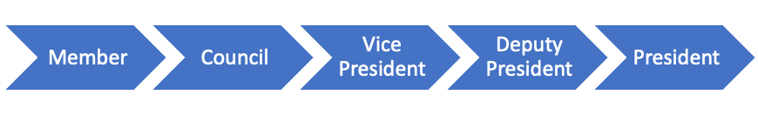
Composition of Council
The INSOL Europe Council is made up of three sections. Reserved Seats, General (Non-Reserved) Seats and Co-opted Directors
Reserved Seats – Each country with 30 or more Members is entitled to a Reserved Seat. The Council Members to a Reserved Seat is elected by the Members in that specific country. Tenure of time for these seats is 3 years with the option should they be re-elected to continue for a further 3 years.
General (Non-Reserved) Seats – There can be a maximum of 6 Council Members in Non-Reserved Seats in total at one time. Two of the seats must be represented by smaller countries that have 20-30 members. The tenure of this is 3 years with the option should they be re-elected to continue for a further 3 years (except for the smaller countries).
Co-opted Directors – There can be a maximum of 8 Co-opted Directors and tenure is 1 year. The Co-opted Directors are appointed by Council and not by election.

General Responsibilities of Council
- Be an advocate of INSOL Europe
- Proactively contribute to INSOL Europe’s success and future
- Raise any external concerns that may harm or effect INSOL Europe
- Approve the annual audit & budget

General Responsibilities of Council Members
- Attend and participate in council meetings: January (online, tbc); March/April (in the hometown of the President); June (online, tbc); October (at the Annual Congress)
- Attend INSOL Europe events
- Raise any other positions held that may entail a conflict of interest
- Promote INSOL Europe whenever possible
- Increase membership in your country – working closely with the Membership Development Committee & Country Coordinator (if applicable)
- Identify & share potential sponsorship leads
- Identify & share any known good speakers for conferences
- Share industry constraints/issues/opportunities in your country that may improve INSOL Europe’s relevance in your country
- Be accountable for regular relevant country updates such as blogs, news and articles for publication on our website, newsletters and Eurofenix
- Respond to requests from the Executive for assistance on ad hoc matters.
- Accept an internal role on Council as proposed by the Executive (available on request)

Why be a Council Member? What is in it for you?
- You will be part of an association that has prestige in Europe, working with key players in the industry (some are members of Council).
- You will build long-lasting relationships, networks and connections which will enhance your business development
- You will be recognised as a key player of the INSOL Europe family and be rewarded for your contribution

Previous Council members have commented:
“Networking is the most primary benefit of being part of the Council it will offer you the chance for better learning, the ability to influence decisions in INSOL Europe. Most importantly it gives you a chance to have a more enriched view and have fun in the process”
“The benefit of working together on various topics, it is also a great way of expanding your own personal network.”

