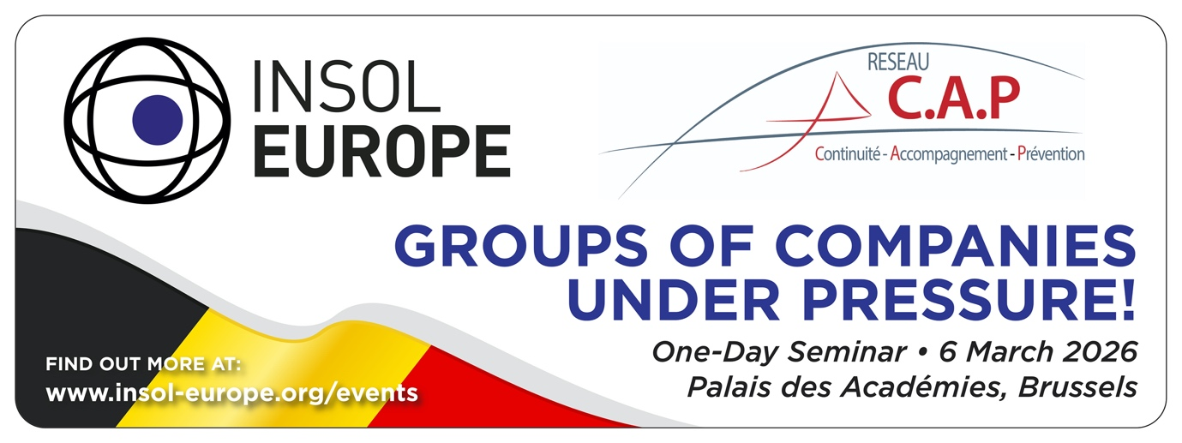

One-day seminar jointly organised by
INSOL Europe & Réseau CAP

Groups of Companies Under Pressure!

Friday 6 March 2026, 10:00 - 17:00
Palais des Académies, Brussels, Belgium

Explore how groups of companies navigate cross-border challenges at this expert-led seminar, featuring EU insights and practical guidance. Conclude the day with an exclusive guided tour of Brussels’ iconic Palais de Justice.

Programme

9h30 - 10h10 - Coffee and tea

Morning session: Chair Bart De Moor

10h10-10h30 - Opening remarks
Speakers:
Alice Van der Schee, Past president, INSOL Europe
Cédric Alter, President, Réseau CAP
Bart De Moor, Country coordinator for Belgium, INSOL Europe

10h30-11h00 - Keynote address
Mr. Ondřej Vondráček (TBC)
Representative from the European Commission
Current EU Commission initiatives on group insolvencies

11h00-11h45 - Panel 1: When Group Structures Are Put to the Test
Key issues: formal proceedings for some entities and not others, intercompany claims, cash pooling, D&O Insurance…
Panellists:
1. Ilya Kokorin, Legal counsel, Autoriteit Financiële Markten, The Netherlands (TBC)
2. Cédric Alter, Janson, Avocat, professor at ULB, Belgium
3. Christel Dumont, Avocat, Dentons, Luxembourg

11h45-12h30 - Panel 2: The Anatomy of Groups of Companies
Key issues: Same directors in various entities; subordination vs. non-hierarchical group, “double Lux-Co” structure
Panellists:
1. Bart De Moor, Advocaat, Strelia, Belgium
2. Isabelle Vincent, Avocat, Simmons & Simmons, France
3. Gregory Minne, Avocat, Arendt, Luxembourg

12h30-13h45 - Networking Lunch
Location: Palais des Académies - Patio

Afternoon session: Chair Cédric Alter

13h45-14h30 - Panel 3: Groups as a Unit: Myth or Reality?
Panellists:
1. Ivan Verougstraete, Former president, Supreme Court (Cour de Cassation), Belgium (TBC)
2. Will Gunston, Lawyer, Osborne Clarke, United Kingdom
3. Michael Thierhoff, Auditor, Forvis Mazars, Germany

14h30-15h15 - Panel 4: One Group, Multiple Proceedings: From Fragmentation to Coordination
Key issues: cooperation between practitioners, territorial and centralised proceedings, recognition of restructuring plans
Panellists:
1. Sid Pepels, Advocaat, Jones Day, The Netherlands
2. Robert Schiebe, Rechtsanwalt, Schiebe und Collegen, Germany (TBC)
3. Alexandra Szekely, Avocat, Le 16 Law, France

16h00-17h00 - Behind the Scenes of the Palais de Justice
Join us for a guided tour of the Brussels Courthouse (Palais de Justice), a landmark of architectural heritage, led by Bart De Moor, lawyer, Strelia, former president of the Brussels Bar.

----------------

Discover Brussels – Optional Side Activities
- Magritte Museum – A cultural immersion on Saturday, celebrating one of Belgium’s most renowned artists
- Further activities will be announced shortly

Time frame
The timing of the seminar has been planned to facilitate same-day travel to and from Belgium for participants from neighbouring countries.

Recommended hotels nearby
The Scott: www.thescotthotel.be
The Hotel: www.thehotel-brussels.be
NH Hotel Grand Sablon: www.nh-collection.com/fr/hotel/nh-collection-brussels-grand-sablon

