Blockchain: A Chance for Turnaround Procedure Modernization
Yutong Zhang

Blockchain brings value reconstruction to assets, including assets digitalization, standardization, registering, and precise pricing. In the “traditional” insolvency practice, there always are three pain points: Asset trace and confirmation of its ownership; Service and asset operation; Asset pricing and evaluation. There is a solid connection between all participants of turnaround procedure. They all can be registered to a Blockchain system. This secured transparent, and efficient connection is credited to the following reasons: The Asset Digitalization and Standardization are the fundamental base; Decentralized Registering are theoretical methods, and the Precise Pricing is a key solution. In a word, blockchain system could open a door for Turnaround Procedure Modernization.

- The Nature of Blockchain System
From a technology perspective, distributed ledger, consensus algorithm, multiple nodes are the substantial parts of understanding a Blockchain system. In its essence, a Blockchain system can be described as a shared and synchronized digital database.
- Information System
The same with Internet, the Blockchain system is an electronic network with information streaming. There are several kinds of information on the Blockchain: participant information, asset information and transaction information.
- Incentive Mechanism
A Blockchain system has a special incentive mechanism driven by a consensus algorithm and a distributed ledger. The mechanism leads to Crypto-Economics or Token-Economics. Associated with the distributed ledger, participants fulfill production, distribution and consumption of goods and services in an encrypted, even tokenized environment. In a word, it is a reward system, participants could get reward based on their activities and performance in the system.
- Trust Mechanism
A Blockchain system is an algorithm-driven, secured, liable environment which provides a solution for data privacy, and information security. Trust mechanism comes out for two reasons. The technologic one relies on the consensus algorithm, encryption algorithms. The structural one would be Smart Contract, which means all the contracts made by participants are shown as various computer programs. All smart contracts can run automatically once conditions are achieved. With the mechanism, digital assets become acceptable.
- The Matching of Turnaround and Blockchain
Different business models have their own logics. For a Blockchain system, all the logics lead to two results – to increase benefits or to reduce costs. Technologies like Blockchain are always options for business like Turnaround if the match points were found.
- Turnaround Modernization
The Turnaround modernization benefits from not only the application of cutting edge technologies, but also the revolution of concept – from business logic driven to data driven. The precise targeting and precise pricing are the future of turnaround business.
- Modernization Solutions for Three Pain Points
Data is vital in next generation. It could be applied to turnaround digitalization at least three aspects for business efficiency: Asset trace and confirmation of its belongingness; Service and asset operation; Asset pricing and evaluation.

- the Junctions of Business and Technology
In the part of asset trace and confirmation of its belongingness, all the information about the assets and participants can be shown through the blocks. In the part of Service and asset operation, service providers are no longer auxiliaries. In the part of Asset pricing and evaluation, the Blockchain system can generate the relatively precise calculation for the asset.
- Turnaround Consortium Blockchain
Consortium Blockchain is the best choice for turnaround business for the consideration of business cost and secrets. Different channels could be added to the Consortium Blockchain in which information only is shared within permissioned nodes.
- Brief Introduction and Basic Model
On Turnaround Consortium Blockchain System, creditors, debtors (trustees or administrators), lawyers, accountants, asset operation experts can work as a common market power. For the function of blockchain system building, all kinds of data could be registered to the system for the purpose of reliable asset and secured data. For the function of trade matchmaking, the debtors and investors/creditors, the debtors and intermediaries, the investors/creditors and intermediaries can strike bargains with each other on the system. For the function of data analysis, tech providers could help to analyze data in many ways including quantitative analysis, neuro-computing, and others to output precise results.
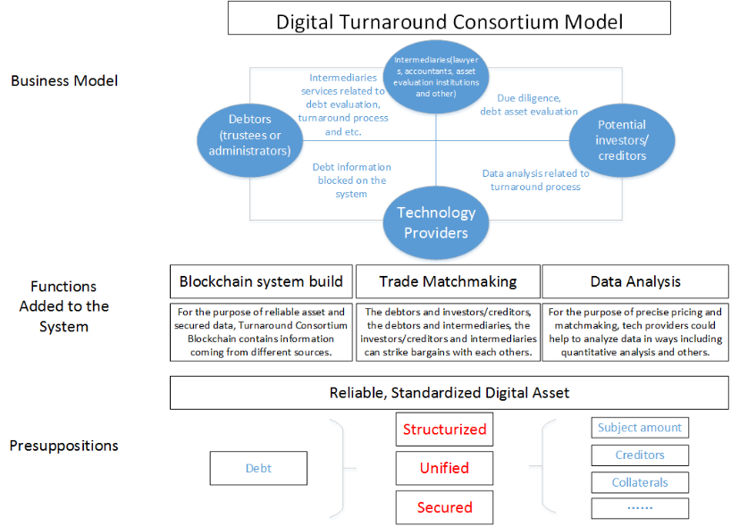

- Participants and Their Roles
One of the advantages of the Turnaround Consortium Blockchain is that different participants could be allocated different authorizations accordingly. Some institutions could play more than one roles in the system.

- Turnaround Process On the System
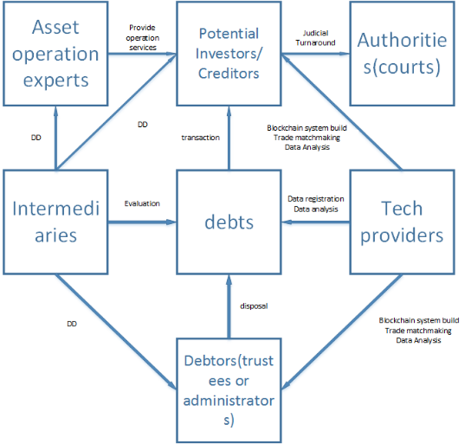
When everyone is registered to the system, the Turnaround process seems like more complex while efficient than traditional ones. From the view of debts, the core is how to deal with them associated with other participants on the system.

- Economic issues
- Economic Value
In the lens of organizations, a Blockchain system is more like a catallaxy. The higher percentage of potential cost saving it might achieve, the more possible a Blockchain system it would deploy.
- Cybersecurity
A Blockchain system is easier to maintain cybersecurity. Hacker attacks could be detected easily if they hacked into the system; the risks from insiders could be eliminated effectively, such as they try to conceal some information or overwrite data.
- Technology Standard
Usually, there would be at least three parts of the standards: (1) the process for data collection, aggregation, analysis, transaction, and storage; (2) the technological procedure for authorities to monitor the turnaround process; (3) the API used to connect with other capital market.
- Legal Concerns
- Legal nature and law Application
Not like a form, a joint venture, an incorporated business organization or partnership, there are not only bilateral activities, but also some multilateral ones. All the transactions and DD and evaluation activities are subjects to contract laws, tort laws, and IP laws.
- Conflict of law in the Cross-board situation
There is always a conflict in Cross-board situation. If the participants came from different areas, they might be subject to multi jurisdictions.
- Data
On a distributed ledger, data can be stored in a variety forms and types. At this stage, blocks have limited storage capacity to keep vast number of data, for instance, movies or digital arts. Data is usually encrypted or hashed before it is added to a Blockchain. Throughout the process, data is chronologically ordered in a manner that makes it difficult to tamper with information without altering subsequent blocks.
- IP Law
In the block system, tech providers develop and maintain the network, and also provide data analysis services to other participants. Will they possess the system? To what extent will tech providers get benefits from of the work and services? There are two approaches for that. First one is called Bitcoin way and another is called Ripple way.
- Regulation
Authorities and regulators are important parts of the system. Apart from that participants could report their activities to them, e.g. accountants shall report their activities to some regulators for annual audits, the system could offer more sophisticated methods for regulators to get insight into network activity.
- Closing Remark
The Blockchain system could transform the model of traditional turnaround process to be efficient. Not only intermediaries are empowered to play a richer role, but also the authorities could achieve a comprehensive regulation goal. Turnaround procedure is an ideal scenario which can directly deploy the system. When applying the Turnaround Consortium Blockchain system, we should pay attention to some concerning issues, including data, economic value, regulation and so on.

Asset operation means real estate management, debt collection and other actions which can increase assets’ value.
Marc Pilkington, Bitcoin through the Lenses of Complexity Theory: Some Non-Orthodox Implications for Economic Theorizing, Handbook of the Geographies of Money and Finance, Pollard, J. & Martin, R. (eds.), Edward Elgar, 2017.
See introduction about HyperLedger Fabric, see https://www.hyperledger.org.
Dirk A. Zetzsche, Ross P. Buckley, Douglas W. Arner, The Distributed Liability of Distributed Ledgers: Legal Risks of Blockchain, EBI Working Paper Series(2017 – no. 14).
Lord Collins, Et. Al., Morris Dicey AND Collins On The Conflict Of Laws (2016); Adrian Briggs, Private International Law In English Courts (2014).
Michèle Finck, Blockchains and Data Protection in the EU, Max Planck Institute for Innovation and Competition Research Paper No. 18-01

